Project - Low Level Design
On
  - Deploy Insurance App to Kubernetes
  - Course Name: DevOps

Institution Name: Medicaps University – Datagami Skill Based Course

Student Name(s) & Enrolment Number(s):
Sr no | Enrollment No | Student Name
1 | Ananya Madanala | EN22CS301119
2 | Anind Bilthariya | EN22CS301129
3 | Arpita Solanki | EN22CS301202
4 | Ashutosh Singh | EN22CS301221
5 | Avani Sharma | EN22CS301240

Group Name: 08D2
Project Number: DO-20
Industry Mentor Name: Mr. Vaibhav
University Mentor Name: Prof. Akshay Saxena
Academic Year: 2025-26

Table of Contents
- Introduction.
  - Scope of the document.
  - Intended Audience
  - System overview.
- System Design.
  - Application Design
  - Process Flow.
  - Information Flow.
  - Components Design
  - Key Design Considerations
  - API Catalogue.
- References

1. Introduction
1.1 Scope of the Document
This document explains how the insurance application is deployed using Docker and Kubernetes. It covers the basic system design, working flow, and how the application is updated without downtime.

1.2 Intended Audience
- Students who want to understand the project
- Teachers and evaluators for reviewing the project
- Beginners in DevOps learning Docker and Kubernetes
- Developers who want to know how the app is deployed
- Anyone with basic programming knowledge for better understanding

1.3 System Overview
- The system is a simple insurance application deployed using Docker and Kubernetes
- The application is packaged into a container using Docker
- Kubernetes is used to run and manage the application
- Multiple copies of the application run to ensure it is always available
- The user accesses the application through a web browser
- Requests are handled by Kubernetes and sent to the application
- Rolling updates are used to update the app without downtime
- The system ensures smooth performance and continuous availability

2. System Design
2.1 Process Flow
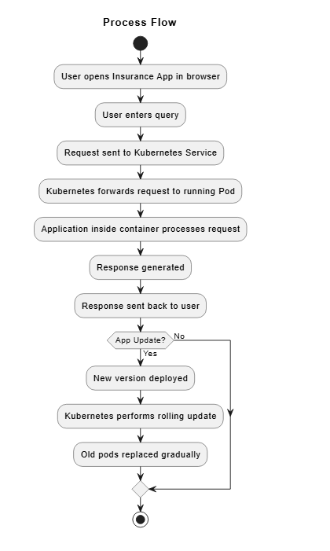

2.2 Information Flow
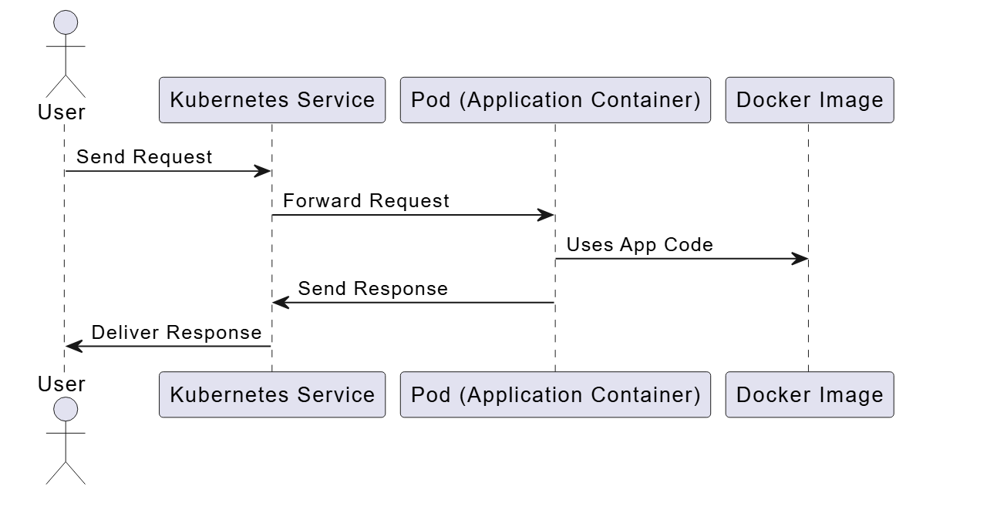

2.5 Key Design Considerations
- High Availability
Multiple instances (pods) of the application are used so that the app is always running even if one fails.
- Zero Downtime Deployment
Rolling updates are used to update the application without stopping it, so users do not face any interruption.
- Scalability
The system can easily increase or decrease the number of application instances based on need.
- Reliability
Kubernetes automatically restarts the application if it crashes, ensuring continuous service.
- Simple Architecture
The system is designed in a simple way using Docker and Kubernetes for easy understanding and implementation.
- Efficient Resource Usage
Proper CPU and memory limits are set to avoid overuse of system resources.
- Easy Deployment
Using Docker makes the application portable and easy to deploy on any system.

Tech Stack:
Category | Technology
Application | Python, Streamlit, Groq API
Containerization | Docker, Docker hub
Orchestration | Kubernetes
Version Control | Git, Github

3. References
- Docker Documentation – https://docs.docker.com
- Kubernetes Documentation – https://kubernetes.io/docs
- GitHub Documentation – https://docs.github.com
- Minikube Documentation – https://minikube.sigs.k8s.io/docs
- Stack Overflow – https://stackoverflow.com (for troubleshooting)
- GitHub
avanisharma-5/Deploy_Insurance_App

